**BINARY TO DECIMAL NUMBER USING C**

**AIM:**

To write a C program to implement binary to decimal conversion.  
  
  
  
  
  
**ALGORITHM:**  
  
  
1)      Store  
the remainder when the number is divided by 8 in an array.  
  
  
2)      Divide  
the number by 8 now  
  
  
3)      Repeat  
the above two steps until the number is not equal to 0.  
  
  
4)      Print  
the array in reverse order now.

**PROGRAM:**

#include<stdio.h>

int main()

{

int decimal=0 ,binary,num,base=1,rem;

printf("Enter any binary number:");

scanf("%d",&num);

binary=num;

while(num>0){

rem=num%10;

decimal=decimal+rem*base;

num=num/10;

base=base*2;

}

printf ( " The binary number is %d\n", binary);

}

**INPUT & OUTPUT:**

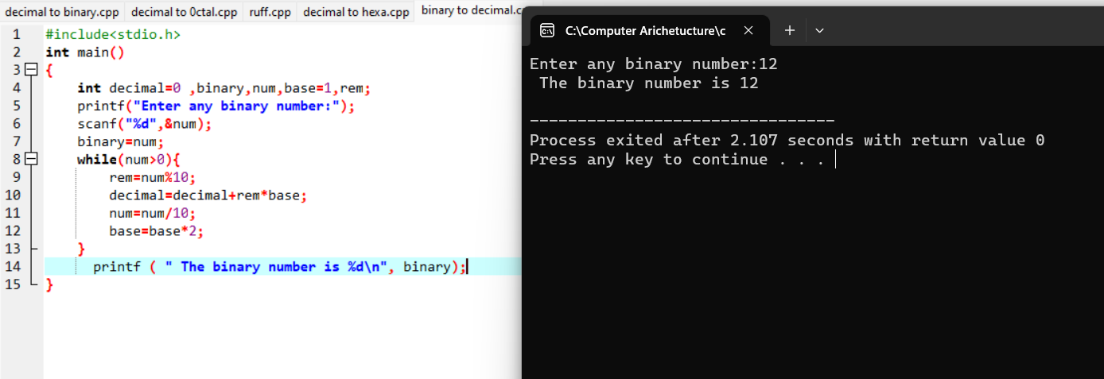

**RESULT:**

Thus we can write the program for Binary to Decimal successfully in

DEV C++.